SCD TYPE 2 IMPLEMENTATION IN NETEZZA
JOB Design:
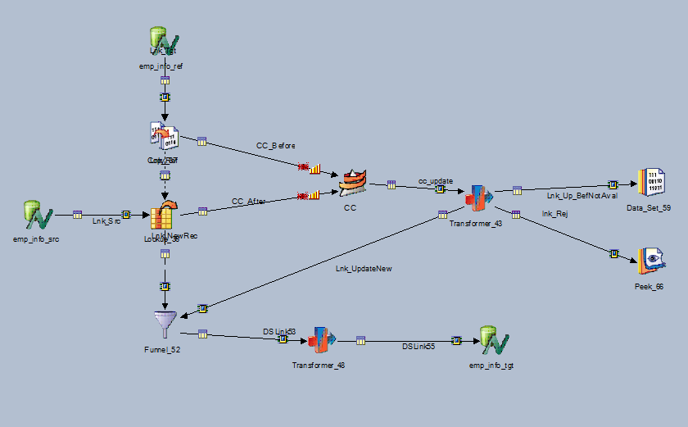
Source Table-
emp_info_src: DP_TDM_MI..emp_INFO_type2_src

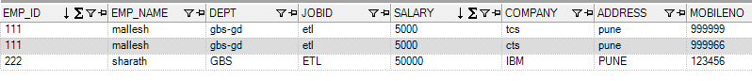
Soruce query:
select distinct
EMP_ID,
EMP_NAME,
DEPT,
JOBID,
SALARY,
COMPANY,
ADDRESS,
MOBILENO
from
emp_INFO_type2_src

Ref cum Tgt table:
CREATE TABLE MI_CONS.EMP_INFO_TYPE2_NEW
(
SKEY INTEGER,
EMP_ID INTEGER,
EMP_NAME CHARACTER VARYING(50),
DEPT CHARACTER VARYING(20),
JOBID CHARACTER VARYING(20),
SALARY INTEGER,
COMPANY CHARACTER VARYING(50),
ADDRESS CHARACTER VARYING(50),
MOBILENO INTEGER,
CLOSE_DT DATE,
OPEN_DATE DATE,
INSERT_DT DATE,
CUR_FLAG CHARACTER VARYING(1),
UPDATE_DT DATE
)
DISTRIBUTE ON (SKEY);

LKP

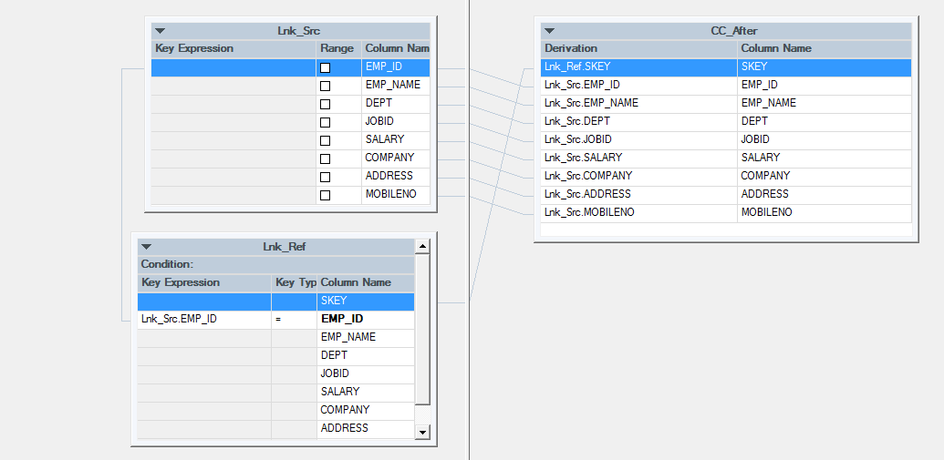

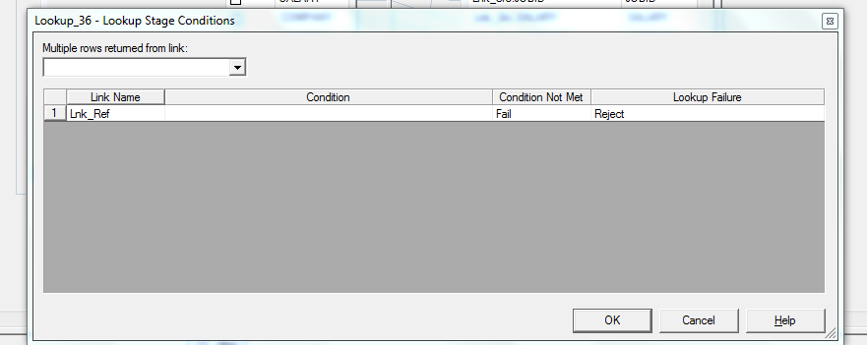

Funnel

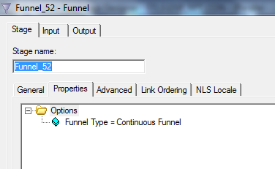

TRS Initial load

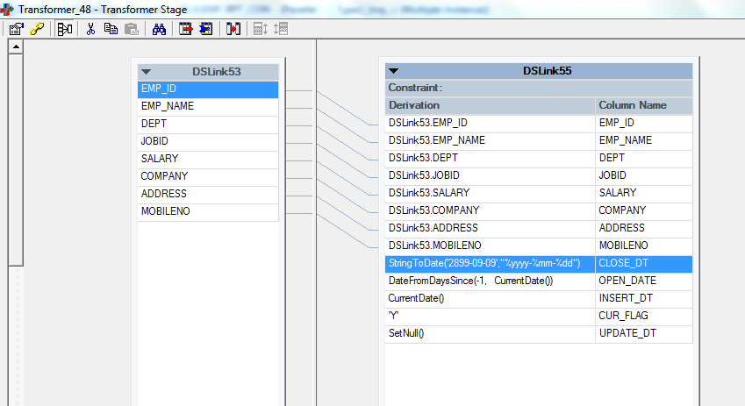

Tgt-table Insert Query NZ SKEY-Gen

insert INTO EMP_INFO_TYPE2_NEW
(
SKEY,
EMP_ID,
EMP_NAME,
DEPT,
JOBID,
SALARY,
COMPANY,
ADDRESS,
MOBILENO,
CLOSE_DT,
OPEN_DATE,
INSERT_DT,
CUR_FLAG,
UPDATE_DT
)
(SELECT
NEXT VALUE FOR EMP_TYPE2_SEQ,
[[twt]].EMP_ID AS EMP_ID,
[[twt]].EMP_NAME AS EMP_NAME,
[[twt]].DEPT AS DEPT,
[[twt]].JOBID AS JOBID,
[[twt]].SALARY AS SALARY,
[[twt]].COMPANY AS COMPANY,
[[twt]].ADDRESS AS ADDRESS,
[[twt]].MOBILENO AS MOBILENO,
[[twt]].CLOSE_DT AS CLOSE_DT,
[[twt]].OPEN_DATE AS OPEN_DATE,
[[twt]].INSERT_DT AS INSERT_DT,
[[twt]].CUR_FLAG AS CUR_FLAG,
[[twt]].UPDATE_DT AS UPDATE_DT
)

TGT_initial load data

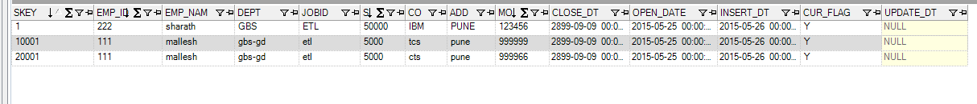

CP

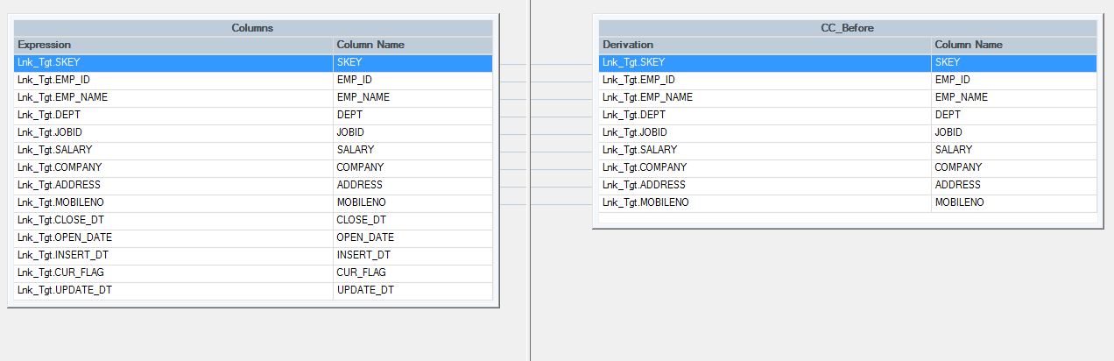
Change Capture
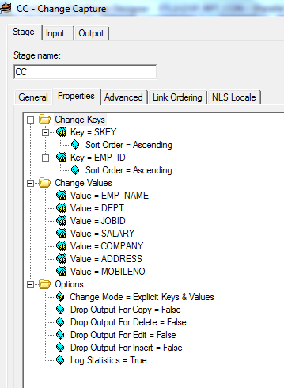
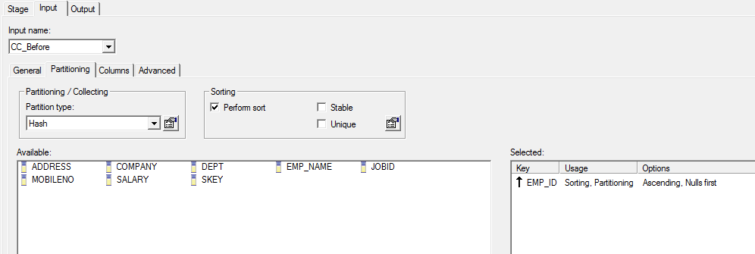

TRS 2
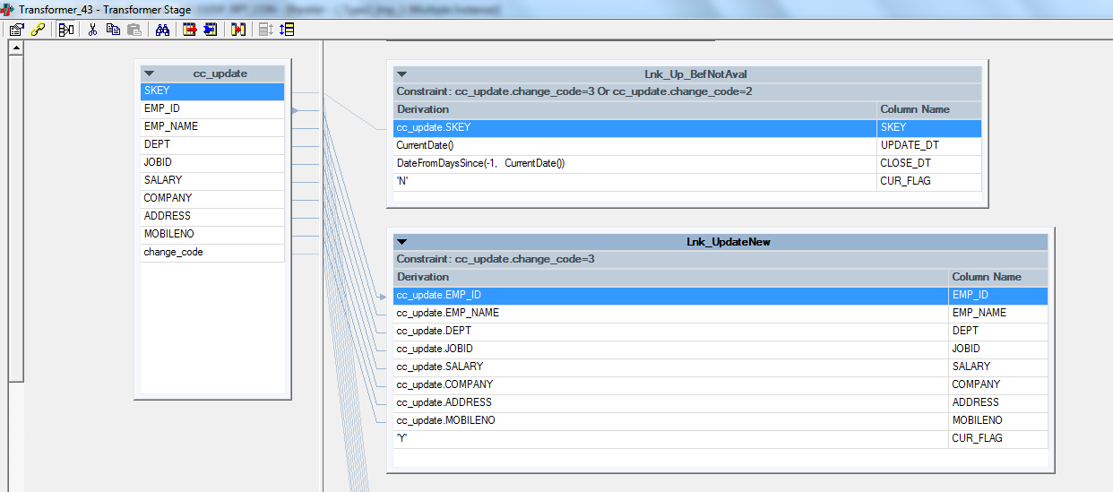

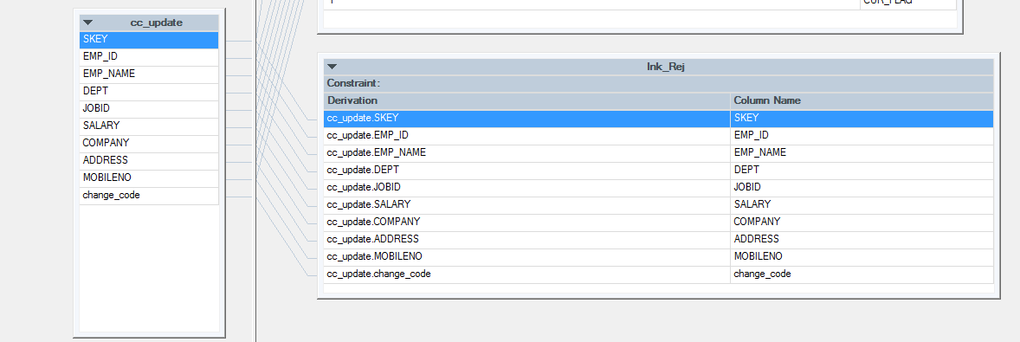
Update&delete data
Data set

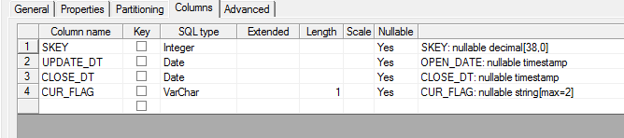

Incremental Load
Dataset
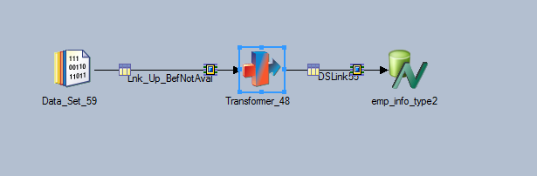
Netezza-Target table
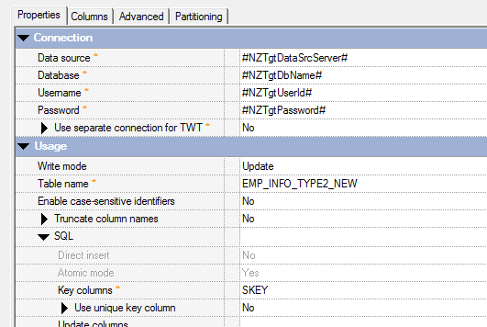

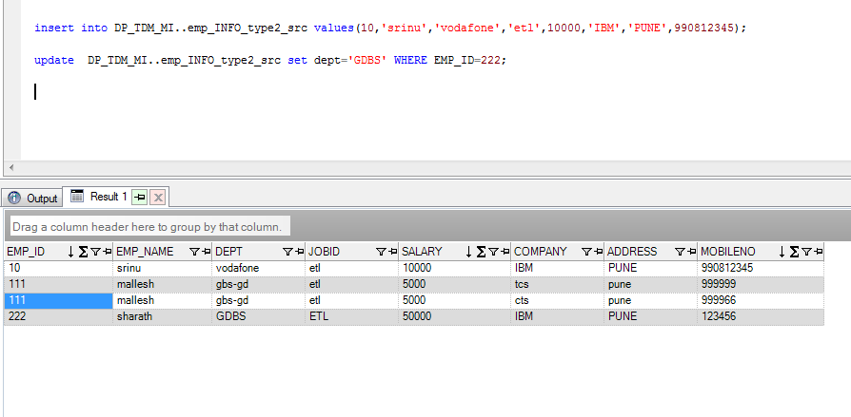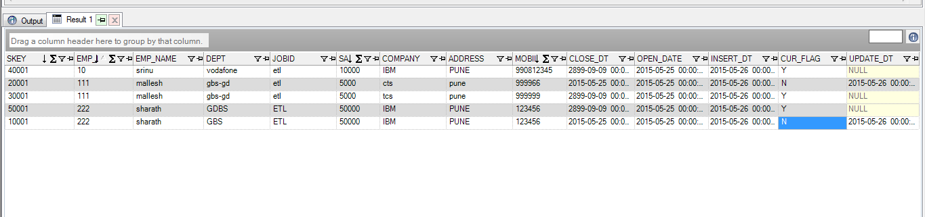
Syntax for Creating sequence
CREATE SEQUENCE Emp_seq_new2 AS BIGINT
START WITH 1
INCREMENT BY 1
NO MINVALUE
MAXVALUE 2147483647
NO CYCLE;

select next value for Emp_seq_new2;

ORACLE – SKEY Gen
INSERT
INTO #P_ETL_SCHEMA#.DIM_VF_RETAIL_TYPE
(
VF_RETAIL_STORE_SKEY ,
VF_RETAIL_STORE_TYPE,
STORE_CODE,
STORE_NAME,
CIRCLE_ID,
BASE_CIRCLE,
ZONE_CD,
BRANCH_CD,
INSERT_DT,
OPEN_DT,
CLOSED_DT,
EXECUTION_ID
)
VALUES
(
VF_RETAIL_TYPE_SEQ.NEXTVAL ,
:VF_RETAIL_STORE_TYPE,
:STORE_CODE,
:STORE_NAME,
:CIRCLE_ID,
:BASE_CIRCLE,
:ZONE_CD,
:BRANCH_CD,
:INSERT_DT,
:OPEN_DT,
:CLOSED_DT,
:EXECUTION_ID
);

sed -n '1p;$p' srinu.txt
head -1 srinu.txt && tail -1 srinu.txt
awk 'NR==1 { print $0}' srinu.txt && awk '{k=$0} END{print k}' srinu.txt

find . -name srinu.txt

